Andrea still is responding in a large block of text. No block should be greater than 40 words. That needs to be built in to her prompt.
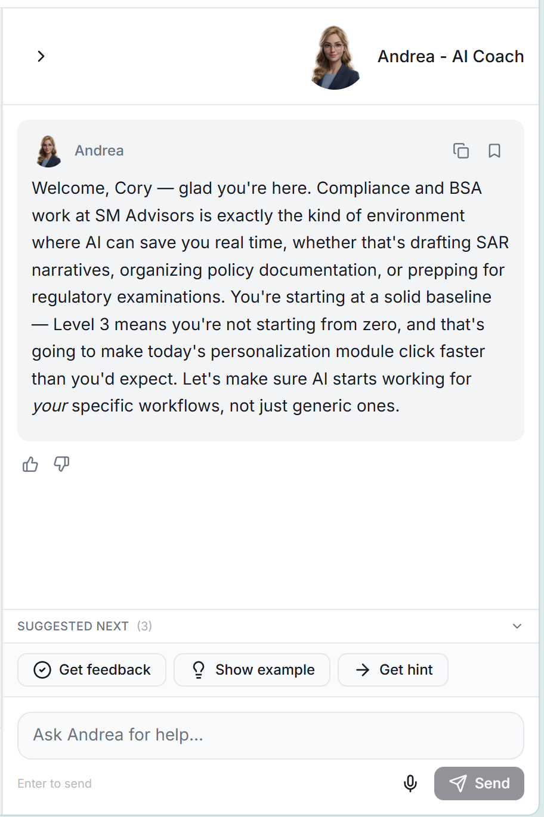

I left this page to click on My Profile. When I returned, my responses and Andrea’s commentary didn’t persist. I want all inputs to be auto saved. If its easiest, I don’t mind the auto save happening like every 5-10 seconds rather than after every keystroke is input.
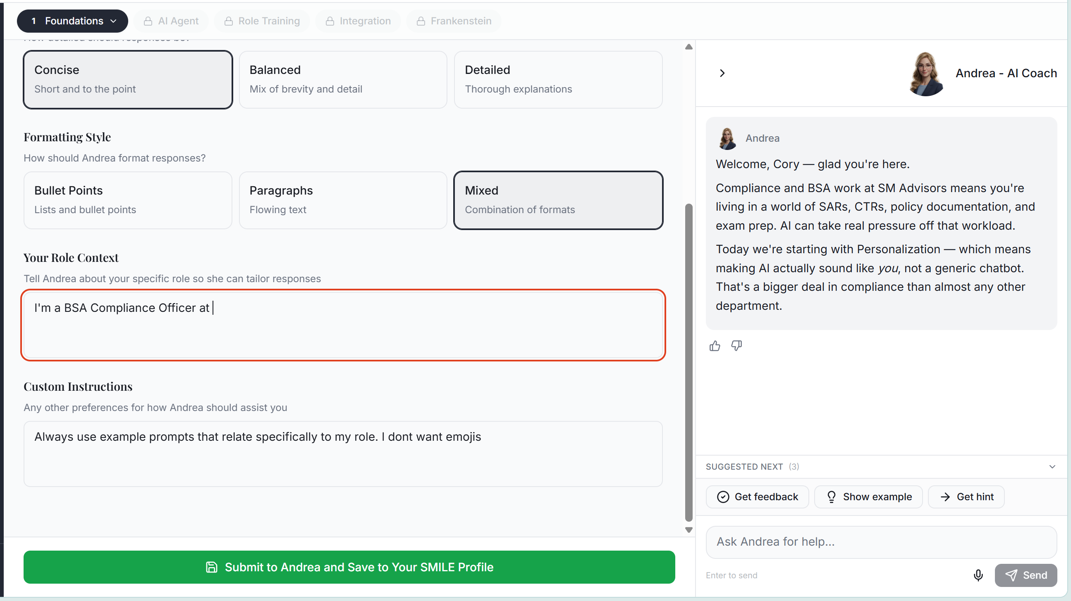

On the intake form, all questions should be multiple choice. There shouldn’t be anything open ended. For the AI skill assessment, I’m fine with crafting 6 questions that will really help hone in on how confident someone is with using AI.
Also, I describe the intake form as 3 domains: What your role is at the organization, What your AI skillset is, and How you like to learn. The purpose of each step in the intake form should be described at the top, very briefly , so a user understands why its important to make this as accurate as possible (meaning it makes their experience tailored to them personally)
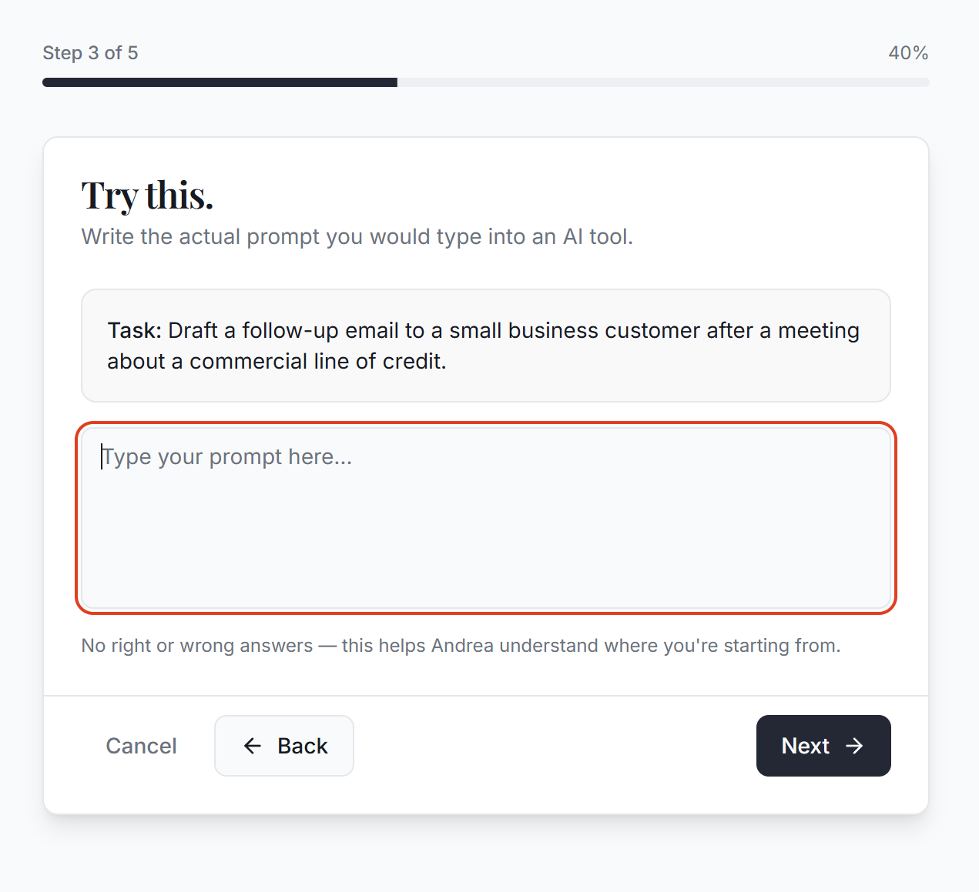

After the user clicks Submit to Andrea and Save to My SMILE profile, Andrea provided feedback. When the user applies the feedback, or edits anything within the chat, for all modules, the ability to click the submission button should open again.
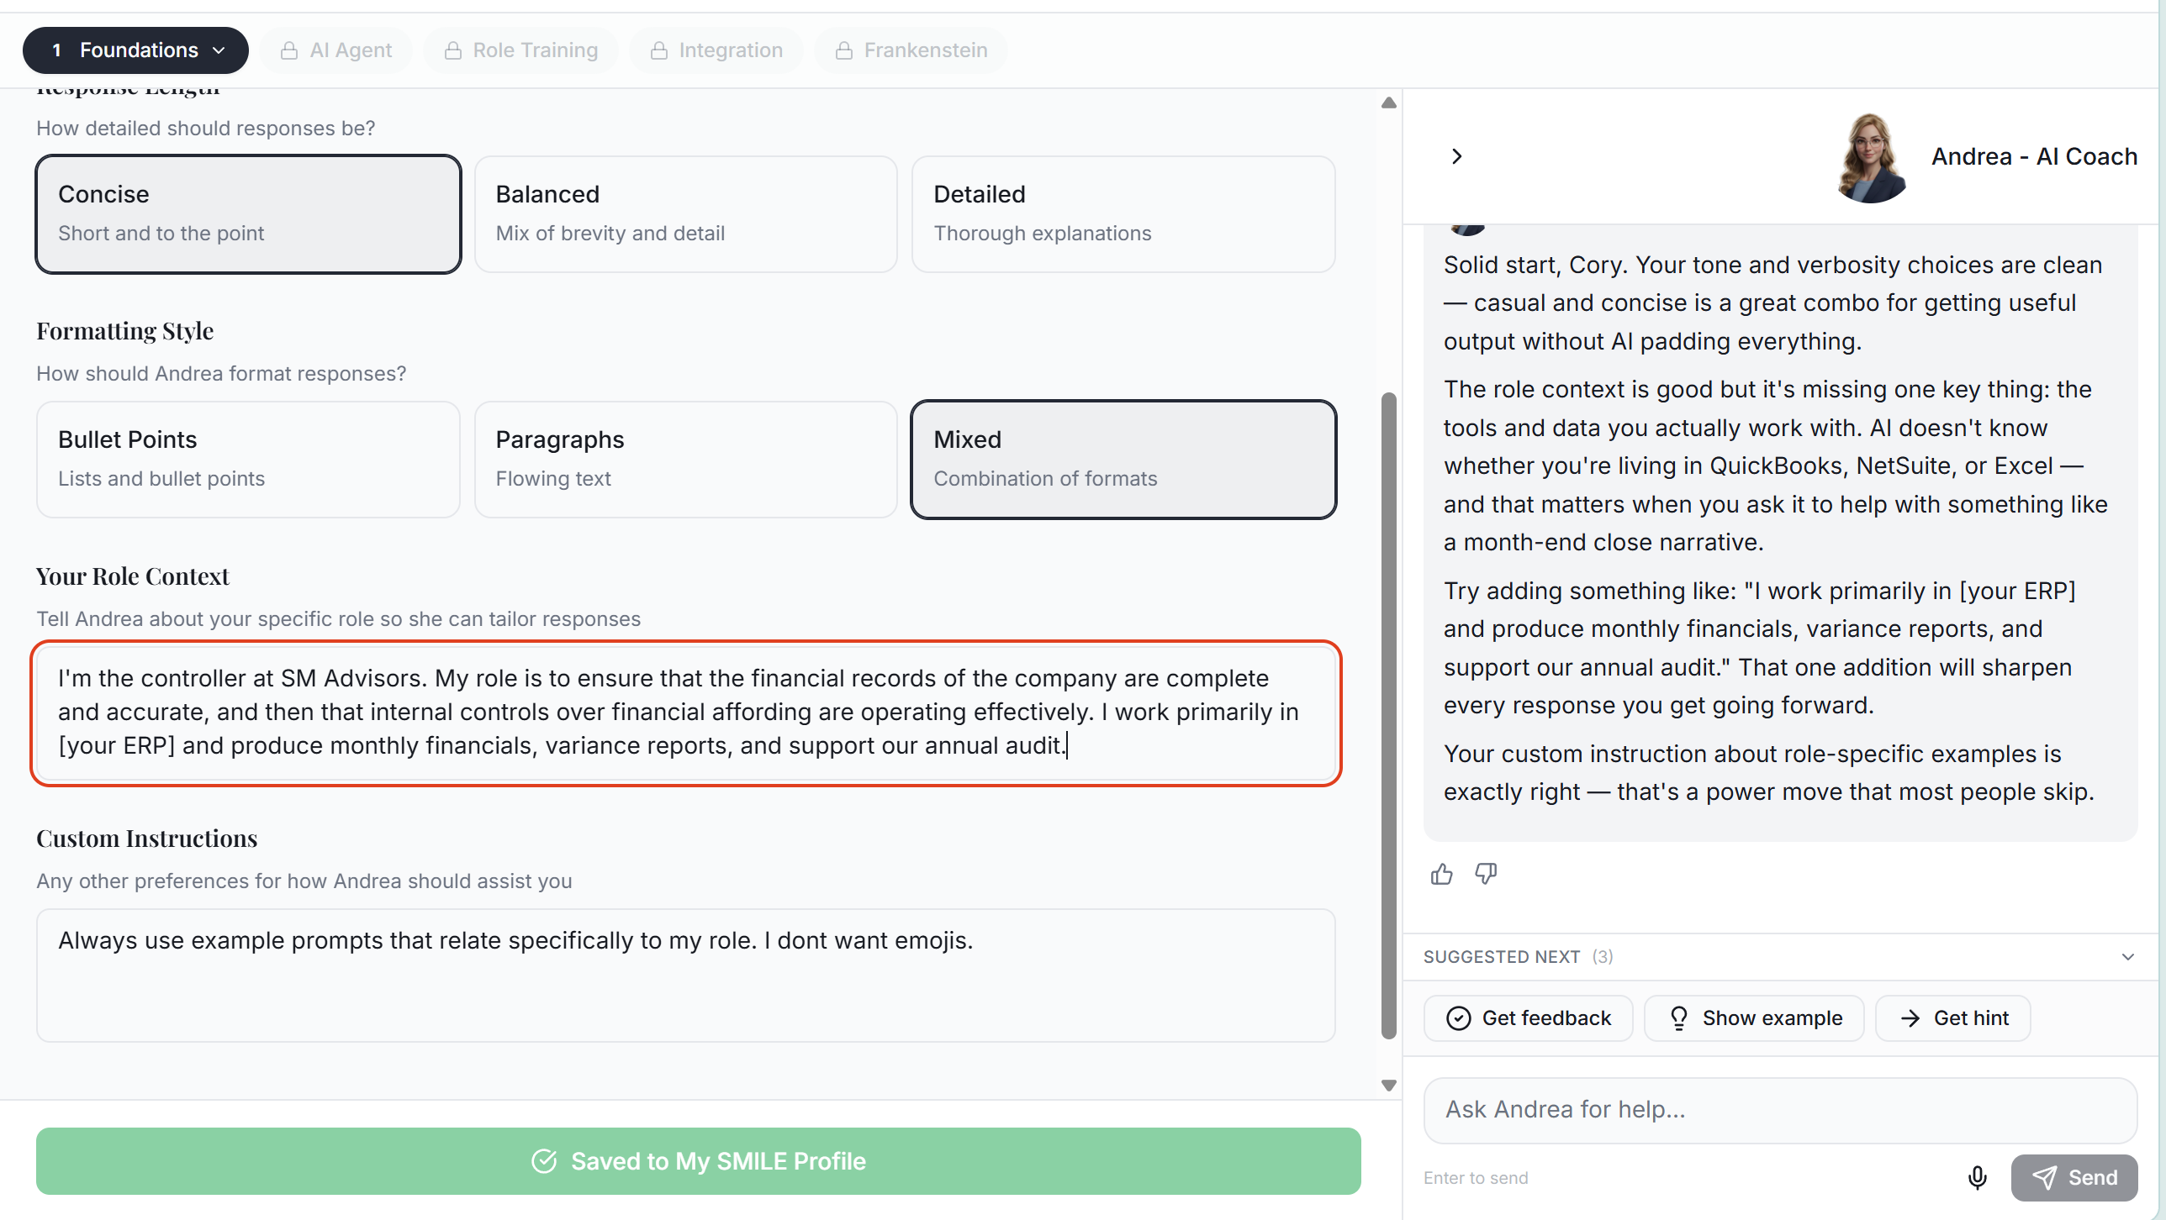
After the user clicks Submit to Andrea and Save to My SMILE profile, Andrea provided feedback. At this point, the “My Profile” should have a pop up notifying the user that they can review their personalization by clicking in the bottom right on their name.


After I submit, there’s nothing to notify me that I can proceed to the next module (or continue working in this module.) That should occur for all modules.
